**Prediction of LC50 value using Quantitative structure–activity**

**relationship models (QSAR models)**

***Wireframe Documentation***

**Home Page**

The project contains only one page i.e., ‘home.html’ includes both html and css for web page. The result is shown in the same ‘home.html’ page with change in the value of prediction ‘/predict’ is added in the address of this page.

Based on the project, the skeleton is developed for the web application.

1. Home page:

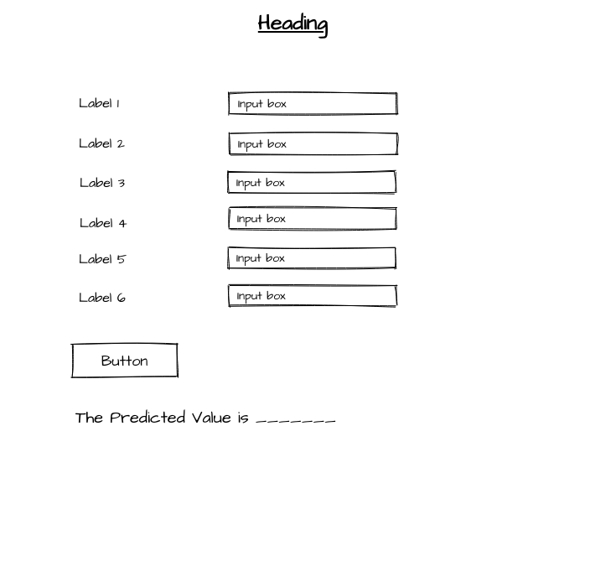

1. Predict page:

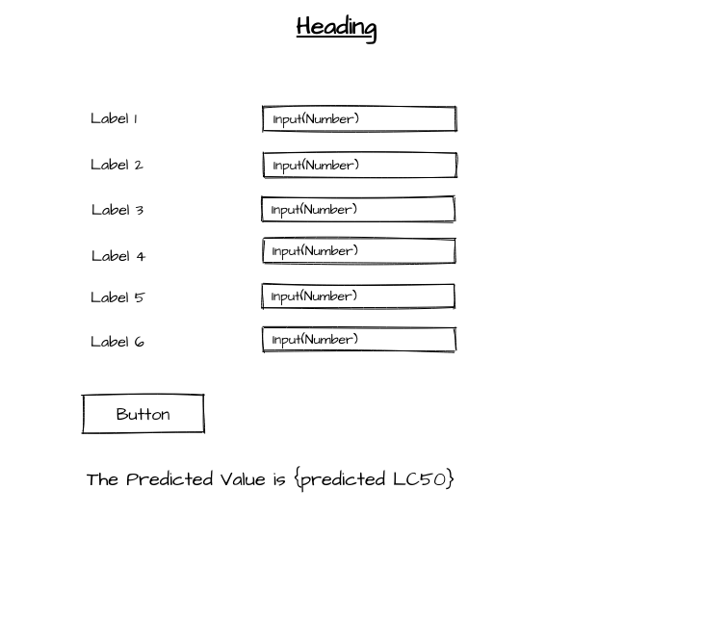

**Home page:**

In the home page we can enter the input in the textbox and click the ‘predict’ button.

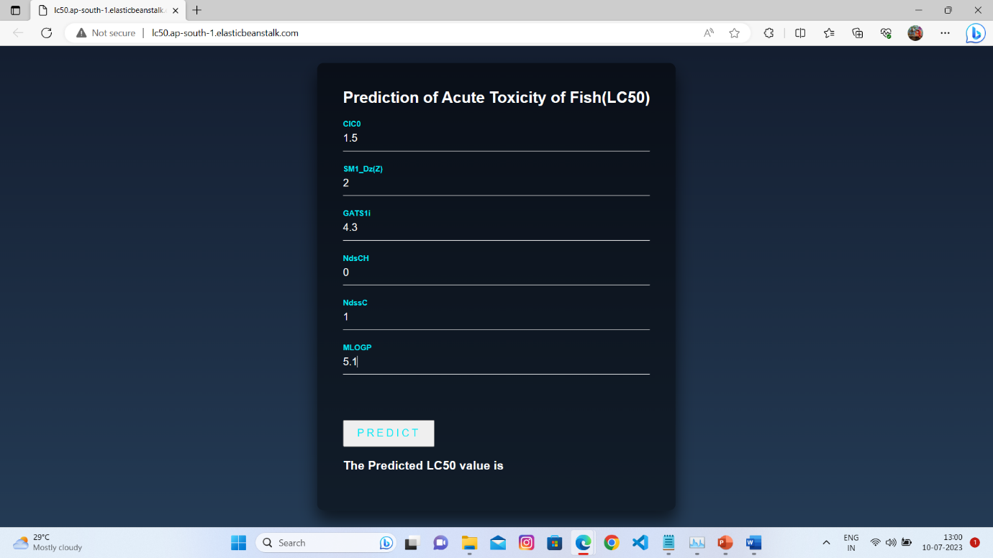

**Predict Page:**

The ‘predict’ page is re-direccted when ‘predict’ button is clicked.

